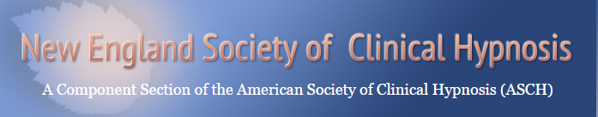

Registration Form

Basic Workshop in Clinical Hypnosis

October 24-25 & November 7-8, 2015
Lasell College - Winslow Academic Center
1844 Commonwealth Avenue, Auburndale, MA 02466

Name: __________________________________________________________________________
Address:__________________________________________________________________________________________________________________________________________________________
Email: __________________________________________________________________________
Phone/ Cell: _______________________________________________________________________
Phone/ Office: _____________________________________________________________________
Phone/ Home: _____________________________________________________________________
Type of License: _________________________________________________________________
Institutional Affiliation: ______________________________________________________________

Tuition: [ ] Early registration (on or before 9/15): $700. [ ] Registration after 9/15: $799

[ ] Trainee/Student: $399 (Required: Letter verifying registrant’s trainee/student status from supervisor or sponsoring institution. Letter must be sent to neschworkshops@gmail.com)

[ ] T/A (TBA)

Cancellation Policy: Cancellations prior to October 19 are subject to a $100 handling fee or attendee can credit the full amount paid, less a $50 handling fee, toward another NESCH program. No refunds after October 19.

Learning Goals: (How are you planning to use hypnosis?)
___________________________________________________________________________________________________
_________________________________________________________________________________________________________________________________________________________________________________________________________________________________________________________________________________________________________

Lunch is included. Please indicate any dietary restrictions here: _______________________________

Completed registration form must be emailed to neschworkshops@gmail.com

Payment Information
Processing Tuition Fee via Check
Application fees are payable by check made out to NESCH or can be processed using Square Cash.
Mail checks to: NESCH Training
C/O Russell Chin, DDS
1288 Newport Ave.
Pawtucket, RI, 02861

Processing Tuition Fee with Square Cash
Square Cash is a service that allows you to literally send and request money via email. There is no need to create a login name or password. All you need is an email account and debit card (SquareCash does NOT accept credit cards) and to follow the steps below.
1. Draft an email with recipient’s email address in the “to” field
In this case, the email should be addressed to ouchin@prodigy.net
2. Enter cash@square.com in the “Cc” field
3. Enter the fee amount in the “Subject” field
4. Add a note to the body of the email saying NESCH Basic Training
5. Send the email

Typically, transactions can take one or two business days to process, but it sometimes happens faster. Please note that if you have not used Square Cash before, you will get an email prompting you to add your Visa or MasterCard debit card information. Once that is set, Square will withdraw the money from your debit card and credit it to the NESCH account.

If you have any questions about using Square Cash, please contact
Staisha Stephens-Brown at neschmsc@gmail.com

